1. **Agenda**: How Spring handles Spring Security and Authorization internally.
2. In industry, the short forms are
   1. Authentication: AUTHN
   2. Authorization: AUTHZ
3. Authorization is optional step.
   1. Thousands of the apps where you don’t need authorization.
   2. Whereas if your app has thousands of users, you may have a requirement **to control the user actions and display of the data** based on roles and authorizations.
4. In the previous section, we saw a user related schema/contract is stored in UserDetails.
5. 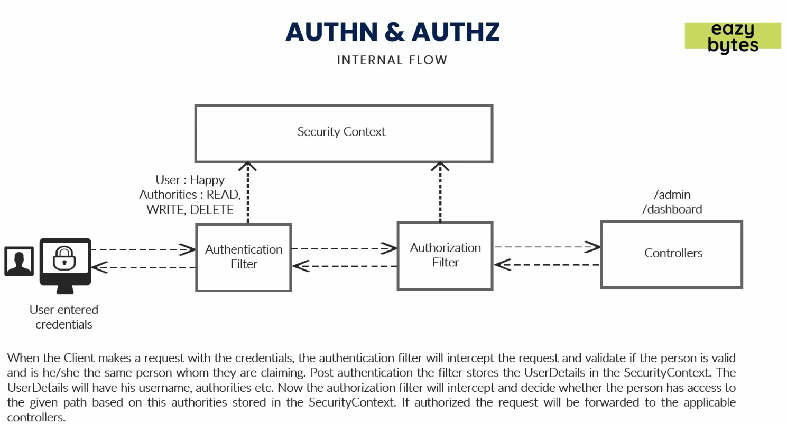
6. Let’s see in the next lecture, where these roles and authorizations in UserDetails are stored inside Security Context.